This document is a work in progress and will be updated as we iron out the remaining challenges in our review processes.

Link to previous work on review process

Changes to the review process

Statuses of an application

Timeline for each review

Statuses of review work

SOP for Technical Coordinator

🌄 Start of Day Routine

☀️ During the day

🌆 End of Day Routine

SOP for APM

🗓️ Daily

🗓️ Weekly

# Link to previous work on review process

[CRM - Vetting Process](https://docs.google.com/document/d/1brmOvXduJXfV3Y5RE_aLPHPqB8HCe2lgAzdWBXKmFiU/edit?usp=sharing)

[DPG Review Policy](https://docs.google.com/document/d/1FdgUJaHP9uDq2-D2nRBj5MBH4nzGL63GpbcddiRtkqE/edit?usp=sharing)

# Changes to the review process

The following changes are being introduced in the current review process.

1. **Only full applications are to be accepted.**
   1. The partial submission option in the form will be removed.
   2. Help Instructions for each question in the form will be added.
   3. A help centre will be introduced that contains help material for applicants.
2. **DPGA tech coordinator will own & do all reviews.**
   1. Accountability of reviews (across all indicators), accountability of the status of each application and accountability of the application pipeline will lie with Nathan.
   2. This is until more full-time reviewers are added to the team.
   3. Justin, Ivan and Conrad are only to be consulted on specific issues at Nathan’s discretion. They will provide their expert opinion only when solicited.
   4. Justin, Ivan and Conrad will not make pass/fail decisions on any indicator. They cannot be delegated review work.
3. **Fixed review capacity**
   1. Up to 5 applications can be under review at any point in time.
   2. There should always be 5 applications under review unless there are no new applications.
4. **Time-bound reviews, one-shot decision.**
   1. Once a review is started, a decision must be made within 5 working days.
   2. Every decision is to be given only after reviewing all 9 indicators.
   3. Partial reviews and temporary decisions are not allowed.
5. **Controlled introduction of priority applications in the review pipeline.**
   1. Request to review an application on priority must come through proper channel (an email from an authorised DPGA secretariat member).
   2. No direct request to Nathan can be made.
   3. All priority applications are to be treated equally. No levels of priority must be assigned.
   4. If the current review capacity is full, a priority application can only be taken under review after pausing review of an application already under review.
6. **Separation between “status of *an application*” & “status of *review work*”.**
   1. Status of an application can be: Application, Nominee, DPG or Ineligible.
   2. Status of review work can be: Waiting, Under Review, or Done.
   3. GitHub Projects Board will be refactored to reflect these. Columns for status of review work. Labels for status of application.
   4. No new statuses, labels or columns must be introduced without consultation and approval of APM Prajakta
7. **Building a reviewers’ reference guide**
   1. An internal guide will be written that will serve as a ready reference document for reviewers to check the interpretation of the standard in situations when making a pass/fail decision on an indicator is not clear.
   2. This document will capture insights from previous reviews so that future reviews take lesser time. Also serves as an interpretation of the Standard. New reviewers joining the team will find this extremely helpful and this will reduce their onboarding time significantly.

**What has not changed:**

There are no changes to the actual review itself. The steps that are followed when an application comes under review – duplication of PR on local machine, fixing json / content, checking for pass/fail of against each standard, running CI test, uploading to repo, closing/merging PRs, etc – are left untouched.

A webapp is being worked upon that will further streamline the process and help reviewers free up most of their time from low-value activities and focus purely on making pass/fail decisions. Everything else will be automated.

Go to [Webapp requirements (master document)](https://docs.google.com/document/u/0/d/17V52Cx4xjy-kO_0Qys3Fe5O3mWCgwr31EZI2y0dxOlc/edit)

# Statuses of an application

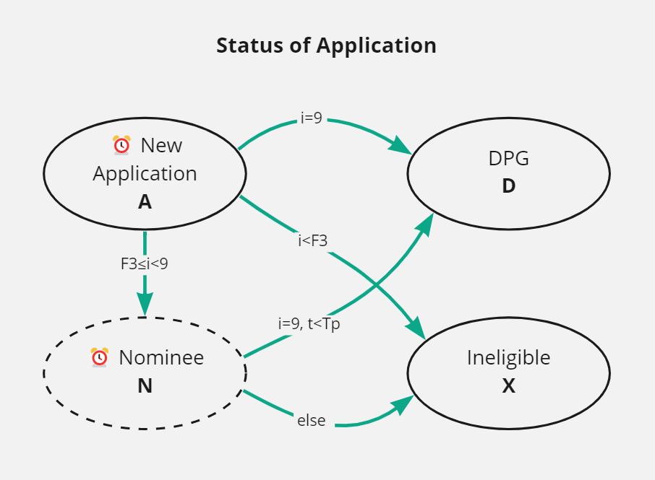

* All applications start as an Application.
* All applications end up either as a DPG or Ineligible (to be a DPG)
  + If an application does not pass the first three indicators, it will be directly declared **Ineligible**. No opportunity to provide clarification will be given in such cases.
  + If an application passes all nine indicators, it will be declared as **DPG**.
* Nominee is a temporary status
  + If an application passes the first three indicators but fails one or more of the rest of the indicators, it will be declared as **Nominee**
  + Nominees are applications with potential to become a DPG
  + They are given one opportunity to provide clarification on the indicators they have failed.
  + Nominees get to enjoy a spot on the registry while they are a nominee.
* There is no dormant or inactive status.

# Timeline for each review



* Once an application has been taken under review, Nathan gets **Tr = 5 working days** to come to a review decision.
* If **Tr** elapses and a decision has not been made yet, the label “**Late**” will be (automatically) added to the application.
* The decision at this point could be either DPG, Nominee or Ineligible depending on indicators passed.
* If the decision is Nominee, Nathan must define time **Tp** and set the timer on the application manually.
* Applicant must respond with relevant clarifications within this time. If they have responded within this time, the label “**Responded**” will be added (manually) to the application.
* When the clarification from the Nominee (which has “Responded”) is reviewed, the decision this time could be either DPG or Ineligible.
* A nominee must not be given more time or requested to give *more* clarification. The onus of providing all relevant information is on the applicant.
* If **Tp** elapses, the label “**Expired**” will be added (automatically) to such application.
* If **Tp** has elapsed, and
  + The applicant has not responded, the application will be declared as Ineligible.
  + The applicant has responded, the application can NOT be declared as Ineligible until the reponse has been reviewed.

# Statuses of review work

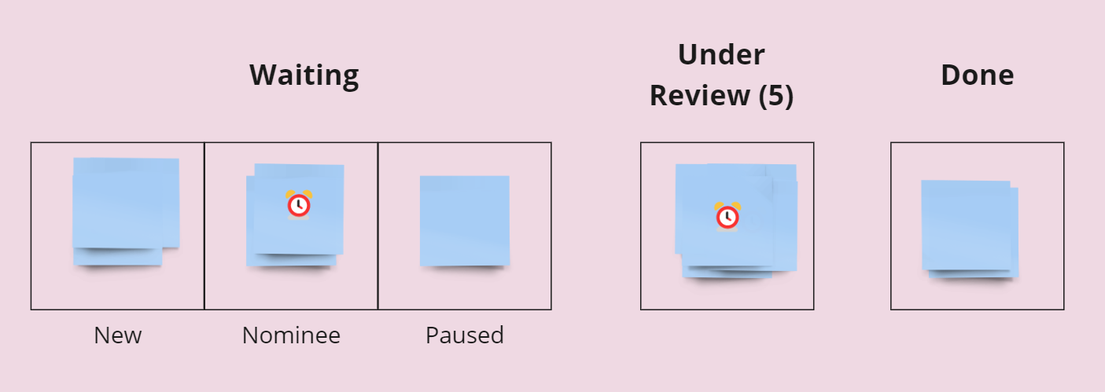

One blue sticky in the diagram represents one application. A sticky note with an alarm clock on it signifies that an automation will kick in when the clock runs out.

1. **Waiting** – applications that are waiting to be reviewed. There are 3 types of application that can exist here:
   * **New**: A fresh submission via the form goes into the New column.
   * **Nominee**: When an application has been reviewed and declared as a Nominee, it sits in Nominee column.
   * **Paused**: When a priority application comes in and the capacity is full, one of the under review applications must be moved to the Paused column to make space for the priority application.
2. **Under Review** – applications that are currently being reviewed by Nathan
   * No more than 5 applications can sit in this column at a time.
   * Once an application is moved here, a review decision must be taken within Tr = 5 working days, including the day it was moved to the Under Review column.
   * If **Tr** elapses and a decision has not been made yet, the label “**Late**” will be (automatically) added to the application to highlight it.
   * “Late” applications must be reviewed before any other under review applications.
3. **Done** – applications that have been reviewed and a final decision has been made.
   * Final decision can be either DPG or Ineligible.
   * Label “Decision:DPG” or “Decision:Ineligible” to be used to identify the decision on application.
   * All “Decision:Ineligible” PRs to be closed.
   * All “Decision:DPG” PRs to be closed and merged.

Note: Priority application to be labeled as “Priority”

# SOP for Technical Coordinator

Summary: Execute the review process and report status & challenges.

### 🌄 Start of Day Routine

*~15 mins, to be done at the beginning of every working day.*

1. Check for responses from nominees
   1. Check support email.
   2. If there is a valid response from a nominee, add **Responded** label to that application.
   3. If you find **Expired** label on that application, check the date of response and the date of expiry. If they responded before expiry, add **Responded** label, otherwise do not add **Responded** label.
2. Clear Expired nominees
   1. Filter applications in **Nominee** column with **Expired** label, but exclude those with **Responded** label.
   2. Force decision = ineligible
3. Fill up capacity (in the following order until the capacity of 5 is reached)
   1. Pull applications from **Paused** column with **Priority** label.
   2. Pull applications from **Nominee** column with both **Responded** & **Priority** labels.
   3. Pull applications from **New** column with **Priority** label.
   4. Pull applications from **Paused** column with no label.
   5. Pull applications from **Nominee** column with **Responded** label.
   6. Pull applications from **New** column with no label.

### ☀️ During the day

While reviewing applications sitting in Under Review column, process them in the following order:

1. Application with **Late** AND **Priority** label.
2. Application with **Late** label
3. Application with **Priority** label
4. Application with no label

If capacity goes to zero but you wants to continue conducting more reviews for the day, refill capacity and continue.

### 🌆 End of Day Routine

*~5 mins, to be done at the end of every working day.*

Update pipeline tracker with the following data as at EOD.

* No. of applications in **New** column
* No. of applications in **Nominee** column
* No. of applications in **Paused** column
* No. of applications with **Priority** label
* No. of applications with **Late** label
* No. of applications moved to **Done** today

# SOP for APM

Summary: Monitor the impact of new process & identify areas for further improvement.

### 🗓️ Daily

*~5 mins*

1. Visit the pipeline tracker.
2. Verify accuracy of data that was entered on the last working day.
3. If there are any Late applications, check in with Nathan about them.

### 🗓️ Weekly

*~30 mins*

* Analyze the flow of applications across different point in the pipeline and see if are any deep insights that can help further improve the process.
* At your discretion, discuss with Nathan any challenges in the execution of the new process.

# Implementation Steps

The above changes will be implemented over the next few days (first week of June 2022).

Following tasks to be done to implement this process:

* Refactoring GitHub Projects Board
  + ~~Update columns~~
  + ~~Update labels (partially done)~~
  + Remove the requirement for approving changes before closing/merging a PR.
  + Remove all reviewers on PRs, except Nathan.
  + Remove PRs that appear on the board but should not. (Only applications should come up on the project board).
  + Add automation (stale PR timer, etc)
  + Migrate Nominee applications that were there in the previous “backlog”
  + Manually check each application in the repo if it is correctly placed & labelled in the board. (some PRs were not showing up in the board)
  + Move applications from Under Review to New / Paused / Nominee until only 5 are left.
* Remove the partial submission option from the form
  + Remove “add nominee” & “add DPG” in PR title.
* Add a help centre and improve the submission form
* Build the reviewers’ reference guide

### 

### Labels:

One: Introducing new labels

| **Label Name** | **Description (to be added on GitHub)** | **Added** |
| --- | --- | --- |
| Priority | Applications who have been approved to be reviewed on priority | Manually |
| Late | Applications that are under review for more than 5 days and decision has not been taken yet. | Automatically |
| Decision:DPG | This application has been reviewed and found to be eligible to become a DPG | Manually |
| Decision:Ineligible | This application has been reviewed and found to be ineligible to become a DPG | Manually |
| Responded | Nominees who have responded within the given timeline. | Manually |
| Expired | Nominees who have not responded within the given timeline. | Automatically |

Two: Clean up old labels

| **Current Labels** | **Relevant PRs / total / closed** | **Action** | |
| --- | --- | --- | --- |
| Digital Public Good | 83/89 | <delete> | Before deleting, move all open PRs to New column. Discuss with Nathan |
| nomination | 61/61 | <delete> | Discuss with Nathan |
| Crowdsourced review | 0 | <delete> | TBD after consultation with Nathan |
| duplicate | 0 | <delete> | TBD after consultation with Nathan |
| enhancement | 0/4 | <delete> | Check if this is related to Issues and needs to be kept |
| excluded nomination | 1/1 | <delete> | Export list elsewhere before deleting this label. Consult with Nathan |
| Documentation | 0/4 | <delete> | Check if this is related to Issues and needs to be kept |
| invalid | 0 | <delete> | TBD after consultation with Nathan |
| ~~Pending Feedback~~ | ~~84/86~~ | ~~<delete>~~ | ~~All reviews owned by Nathan only, so not required anymore.~~ |
| ~~Pending Review~~ | ~~43/48~~ | ~~<delete>~~ | ~~All reviews owned by Nathan only, so not required anymore.~~ |
| ~~technical review~~ | ~~40/40~~ | ~~<delete>~~ | ~~All reviews owned by Nathan only, so not required anymore.~~ |
| ~~Review/QA~~ | ~~7/8~~ | ~~<delete>~~ |  |
| ~~prio:high~~ | ~~7/7~~ | ~~Priority~~ |  |
| ~~prio:normal~~ | ~~4/5~~ | ~~Priority~~ |  |
| ~~needs-traige~~ | ~~3/4~~ | ~~<delete>~~ |  |
| ~~good first issue~~ | ~~0/2~~ | ~~<delete>~~ |  |
| ~~archive~~ | ~~1/1~~ | ~~<delete>~~ | ~~Take a screenshot of related PRs before deleting~~ |
| ~~Weather & Climate Information Services~~ | ~~1/1~~ | ~~<delete>~~ | ~~Only 1 PR exists with this tag~~ |
| ~~Refresher review~~ | ~~1/1~~ | ~~<delete>~~ | ~~Refresher application to be treated as fresh applications. Move 1 PR with this tag to New column~~ |
| ~~Patch~~ | ~~0/1~~ | ~~<delete>~~ | ~~Only 1 PR exists with this tag~~ |
| ~~Climate Change Adaption COP~~ | ~~1/1~~ | ~~<delete>~~ | ~~Only 1 PR exist and same as Weather & Climate.~~ |
| ~~wontfix~~ | ~~0~~ | ~~<delete>~~ |  |
| ~~question~~ | ~~0~~ | ~~<delete>~~ |  |
| ~~prio:low~~ | ~~0~~ | ~~<delete>~~ |  |
| ~~help wanted~~ | ~~0~~ | ~~<delete>~~ |  |
| ~~dependencies~~ | ~~0~~ | ~~<delete>~~ | ~~Take a screenshot of related PRs before deleting~~ |
| ~~bugfix~~ | ~~0~~ | ~~<delete>~~ |  |
| ~~bug~~ | ~~0~~ | ~~<delete>~~ |  |
| ~~Immunization Delivery Management~~ | ~~0~~ | ~~<delete>~~ |  |
| ~~Hacktoberfest~~ | ~~0~~ | ~~<delete>~~ |  |
| Pathfinding pilots | 0/2 | No change |  |
| UNDP CDO | 5/5 | No change |  |
| Health Community of Practice | 0 | No change |  |
| Fintech For Impact | 0/1 | No change |  |
| UNICEF Venture Fund | 4/8 | No change |  |

|  | | Current status of review | | |
| --- | --- | --- | --- | --- |
| **Review not started** | **Reviewed, waiting for feedback from other reviewers** | **Reviewed, waiting for clarification from applicant** |
| Type of application | **Add nominee** | Send them an email asking for full submission and delete the PR | | |
| **Add DPG** | move them to **New** | move them to **Paused** | send them email giving them a deadline and move them to **Nominee** and set time with Tp |

All possible PR-with-labels combinations in each column:

| **New** | **Nominee** | **Paused** | **Under Review** | **Done** |
| --- | --- | --- | --- | --- |
| No label | No label | No label | No label | Decision:DPG |
| Priority | Expired | Priority | Priority | Decision:Ineligible |
| - | Responded | - | Late | - |
| - | Expired + Responded | - | Priority + Late | - |
| - | Expired + Priority | - | - | - |
| - | Responded + Priority | - | - | - |
| - | Expired + Responded + Priority | - | - | - |